

**American International University- Bangladesh**

**CSC 1205: Object Oriented Programming 1 (JAVA)**

**CO4 Evaluation**

**Project Concluding Report**

**Spring 19-20**

**Group ID:**

**Project Title: Currency Converter**

|  |  |
| --- | --- |
| Student Name | Student Id |
| B,M Rahful Hasan Shawon | **18-38270-2** |
|  |  |

**Introduction:**

*A currency converter is software code that is designed to convert one*[*currency*](https://en.wikipedia.org/wiki/Currency)*into another in order to check its corresponding value. The code is generally a part of a* [*desktop app*](https://en.wikipedia.org/wiki/Mobile_app)*and it is based on current market or bank*[*exchange rates*](https://en.wikipedia.org/wiki/Exchange_rate)*. The*[*application software*](https://en.wikipedia.org/wiki/Application_software)*then calculates and displays the corresponding amount of*[*money*](https://en.wikipedia.org/wiki/Money)*.  convert one currency into another, a user enters an amount of money (example: '10000') and chooses the currency he/she wishes to check the monetary value of (e.g. '*[*United States Dollar*](https://en.wikipedia.org/wiki/United_States_Dollar)*'). After that, the user selects one, or sometimes several other currencies, he/she would like to see the result in this application.*

**Problem Analysis:**

*In this application user must gives a input number. If user forget input number this application is gives a error message .If user give any kind of string number this application gives an error. And gives a error message .If the user wants more number of inputs can be given.This project window size is limited.*

**UI Design Analysis:**  
*First the user will choose a country. Then input money. Then press Convert Bottom. Finally user Show output .It is very Simple method.* *As this project was made by the use of GUI, many of its functions were applied. Such as, JFrame , JLabel, JButton,JTextfield,JTextArea and many more.*

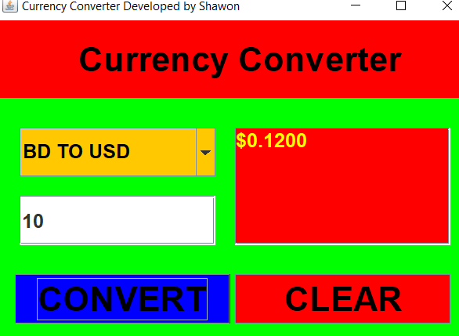 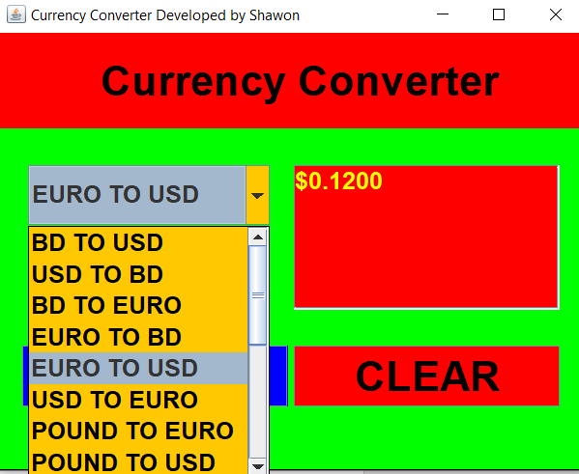

**Logical Analysis:**

*There are three type of logic applied in this application. Yes the applied logics working properly.*

*The logic is it calculate any type of number value .Erase All value pressing clear bottom. Decimal value is four point showing in result. If user did not give any number it showing a error message. It check always which array are selected.*

*The logical operator are two used in this application. one is multiplication Another is Divided. Such as when we convert Bd to Indian its multiply input amount *0.90. When we convert Indian to Bd its divided input amount /0.90.*

*double INDIAN = BD * 0.90;*

*double BD = INDIAN / 0.90;*

**OOP Concept Analysis:**

[***Inheritance***](https://www.geeksforgeeks.org/inheritance-in-java/)***:****Inheritance is an important pillar of Object Oriented Programming. It is the mechanism in java by which one class is allow to inherit the fields and methods of another class.*

[***Class***](https://www.geeksforgeeks.org/classes-objects-java/)***:****A class is a user defined blueprint or prototype from which objects are created. It represents the set of properties or methods that are common to all objects of one type. In general, class declarations can include these components.*

[***Method***](https://www.geeksforgeeks.org/methods-in-java/)***:****A method is a collection of statements that perform some specific task and return result to the caller. A method can perform some specific task without returning anything.*

[***Access Modifier***](https://www.geeksforgeeks.org/access-modifiers-java/)*: The access modifiers in Java specifies the accessibility or scope of a field, method, constructor, or class. We can change the access level of fields, constructors, methods, and class by applying the access modifier on it.*

[***Polymorphism***](https://www.geeksforgeeks.org/polymorphism-in-java/)***:****Polymorphism refers to the ability of OOPs programming languages to differentiate between entities with the same name efficiently. This is done by Java with the help of the signature and declaration of these entities.*

[***Object***](https://www.geeksforgeeks.org/classes-objects-java/)***:****It is a basic unit of Object Oriented Programming and represents the real life entities. A typical Java program creates many objects, which as you know, interact by invoking methods.*

***M***[***essage Passing***](https://www.geeksforgeeks.org/message-passing-in-java/)***:****Objects communicate with one another by sending and receiving information to each other. A message for an object is a request for execution of a procedure and therefore will invoke a function in the receiving object that generates the desired results. Message passing involves specifying the name of the object, the name of the function and the information to be sent.*

***Package:*** *A package is a namespace that organizes a set of related classes and interfaces. Conceptually we can think of packages as being similar to different folders an our computer.*

**Impact of this Project:**

*When was the last time we purchased something from an international E-commerce chain. Or, expand we own business, internationally. It May be, our suppliers are based outside our country, and hence there is a difference in currencies when carrying out transactions. Currency converters aim to maintain real-time information on current market or bank exchange rates, so that the calculated result changes whenever the value of either of the component currencies does. This is why a currency converter app is a convenient invention. People can easily find out about the currency of different countries through the project. And this is a very simple method application.*

**Limitations and Possible Future Improvements:**

*This project is only Desktop base project.* *There is some lacking in this project. Very few things in this application can be improved in future. It don’t use any android or iso device. This application windows size is fixed. It possible Future Improvements in data base adding and many features. Such as all Currency is adding in this application. Online version features are adding. We know currency sometimes increased and decreased. We record this data in future Improvement. And making it Android and iso version also.*

***[Note: Make sure that your report is maximum 3 pages (including cover page).]***